**GREEN VISIT CODE**

***LOGIN***

***activity_login***

*<?***xml version="1.0" encoding="utf-8"***?>*<**FrameLayout xmlns:android="http://schemas.android.com/apk/res/android"  
 xmlns:app="http://schemas.android.com/apk/res-auto"  
 xmlns:tools="http://schemas.android.com/tools"  
 android:layout_width="match_parent"  
 android:layout_height="match_parent"  
 tools:context=".MainActivity"  
 android:orientation="vertical"  
 android:background="@drawable/forest"**>  
 <**LinearLayout  
 android:layout_width="300dp"  
 android:layout_height="500dp"  
 android:layout_gravity="center"  
 android:orientation="vertical"  
 android:paddingLeft="20dp"  
 android:paddingRight="20dp"  
 android:background="@color/transparent_black_80"**>  
  
  
  
 <**TextView  
 android:id="@+id/t1"  
 android:layout_width="376dp"  
 android:layout_height="62dp"  
 android:gravity="center"  
 android:text="Sign in"  
 android:textColor="@color/LightSalmon"  
 android:layout_marginTop="23dp"  
 android:textSize="30dp"  
 android:layout_gravity="center"  
 android:textStyle="bold|italic"** />  
  
  
 <**EditText  
 android:id="@+id/e1"  
 android:layout_width="match_parent"  
 android:layout_height="wrap_content"  
 android:hint="@string/Email_or_Phone_number"  
 android:inputType="text"  
 android:maxLength="20"  
 android:maxLines="2"  
 android:textColorHint="@color/white"  
 android:textSize="23dp"  
 android:layout_marginTop="23dp"  
 android:textStyle="italic"** />  
  
 <**EditText  
 android:id="@+id/e2"  
 android:layout_width="match_parent"  
 android:layout_height="wrap_content"  
 android:hint="Password"  
 android:maxLength="20"  
 android:maxLines="2"  
 android:textColorHint="@color/white"  
 android:textSize="23dp"  
 android:textStyle="italic"** />  
  
  
 <**Button  
 android:id="@+id/b1"  
 android:layout_width="100dp"  
 android:layout_height="40dp"  
 android:layout_gravity="center"  
 android:layout_marginTop="40dp"  
 android:background="@color/blue"  
 android:text="Sign in"  
 android:textColor="@color/white"** />  
  
 <**TextView  
 android:layout_width="match_parent"  
 android:layout_height="wrap_content"  
 android:text="Forgot Password ?"  
 android:textColor="@color/white"  
 android:textSize="19dp"  
 android:gravity="center"  
 android:layout_marginTop="23dp"**/>  
  
 <**TextView  
 android:layout_width="match_parent"  
 android:layout_height="wrap_content"  
 android:text="OR"  
 android:textColor="@color/white"  
 android:textSize="15dp"  
 android:gravity="center"  
 android:layout_marginTop="15dp"**/>  
  
 <**Button  
 android:id="@+id/b2"  
 android:layout_width="150dp"  
 android:layout_height="40dp"  
 android:layout_gravity="center"  
 android:layout_marginTop="20dp"  
 android:background="@color/blue"  
 android:text="Sign up"  
 android:textColor="@color/white"**/>  
  
  
  
 </**LinearLayout**>  
  
  
  
</**FrameLayout**>

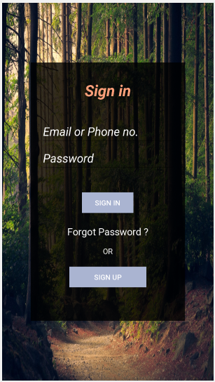

***SIGN-UP***

***activity_signup***

*<?***xml version="1.0" encoding="utf-8"***?>*<**FrameLayout xmlns:android="http://schemas.android.com/apk/res/android"  
 xmlns:app="http://schemas.android.com/apk/res-auto"  
 xmlns:tools="http://schemas.android.com/tools"  
 android:layout_width="match_parent"  
 android:layout_height="match_parent"  
 tools:context=".signup"  
 android:background="@color/transparent_black_80"  
 android:orientation="vertical"**>  
  
 <**LinearLayout  
 android:layout_width="match_parent"  
 android:layout_height="731dp"  
 android:layout_gravity="center"  
 android:orientation="vertical"  
 android:paddingLeft="20dp"  
 android:paddingRight="20dp"**>  
  
 <**RelativeLayout  
 android:layout_width="match_parent"  
 android:layout_height="wrap_content"**>  
  
 <**de.hdodenhof.circleimageview.CircleImageView  
 android:id="@+id/img3"  
 android:layout_width="144dp"  
 android:layout_height="140dp"  
 android:layout_marginLeft="125dp"  
 android:layout_marginTop="50dp"  
 android:src="@drawable/green"** />  
 </**RelativeLayout**>  
  
 <**TextView  
 android:id="@+id/t1"  
 android:layout_width="376dp"  
 android:layout_height="62dp"  
 android:gravity="center"  
 android:text="Create Account"  
 android:textColor="@color/white"  
 android:textSize="25dp"  
 android:textStyle="bold"** />  
  
  
 <**EditText  
 android:id="@+id/e1"  
 android:layout_width="match_parent"  
 android:layout_height="wrap_content"  
 android:hint="Enter the Name"  
 android:inputType="text"  
 android:maxLength="20"  
 android:maxLines="2"  
 android:textColorHint="@color/white"  
 android:textSize="23dp"  
 android:textStyle="italic"** />  
  
 <**EditText  
 android:id="@+id/e2"  
 android:layout_width="match_parent"  
 android:layout_height="wrap_content"  
 android:hint="Enter the Email"  
 android:maxLength="20"  
 android:maxLines="2"  
 android:textColorHint="@color/white"  
 android:textSize="23dp"  
 android:textStyle="italic"** />  
  
 <**EditText  
 android:id="@+id/e3"  
 android:layout_width="match_parent"  
 android:layout_height="wrap_content"  
 android:hint="Enter the password"  
 android:inputType="numberPassword|textWebPassword"  
 android:maxLength="8"  
 android:textColorHint="@color/white"  
 android:textSize="23dp"  
 android:textStyle="italic"** />  
  
 <**EditText  
 android:id="@+id/e4"  
 android:layout_width="match_parent"  
 android:layout_height="wrap_content"  
 android:hint="Confirm Password"  
 android:textColorHint="@color/white"  
 android:textSize="23dp"  
 android:textStyle="italic"** />  
  
 <**EditText  
 android:id="@+id/e5"  
 android:layout_width="match_parent"  
 android:layout_height="wrap_content"  
 android:hint="Enter the Phone no."  
 android:inputType="text|number"  
 android:maxLength="20"  
 android:maxLines="2"  
 android:textColorHint="@color/white"  
 android:textSize="23dp"  
 android:textStyle="italic"** />  
  
 <**Button  
 android:id="@+id/b1"  
 android:layout_width="300dp"  
 android:layout_height="50dp"  
 android:layout_gravity="center"  
 android:layout_marginTop="40dp"  
 android:background="@color/blue"  
 android:text="Signup"  
 android:textColor="@color/white"** />  
  
  
  
  
 <**TextView  
 android:id="@+id/t2"  
 android:layout_width="match_parent"  
 android:layout_height="wrap_content"  
 android:layout_marginTop="10dp"  
 android:text="Already have an account ? Login"  
 android:textColor="@color/white"  
 android:textSize="15dp"  
 android:textStyle="bold"  
 android:layout_marginLeft="50dp"  
 android:layout_marginRight="50dp"** />  
 </**LinearLayout**>  
  
  
  
</**FrameLayout**>

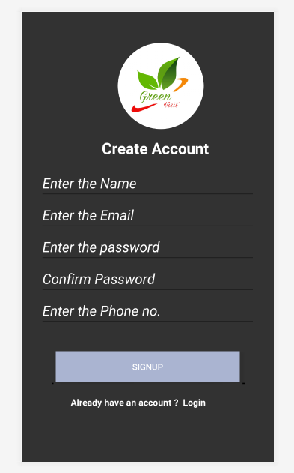

***HOME_PAGE***

***activity_homepage***

*<?***xml version="1.0" encoding="utf-8"***?>*<**RelativeLayout xmlns:android="http://schemas.android.com/apk/res/android"  
 xmlns:app="http://schemas.android.com/apk/res-auto"  
 xmlns:tools="http://schemas.android.com/tools"  
 android:layout_width="match_parent"  
 android:layout_height="match_parent"  
 tools:context=".home_page"  
 android:orientation="horizontal"  
 android:background="@color/transparent_black_80"**>  
  
 <**LinearLayout  
 android:layout_width="match_parent"  
 android:layout_height="115dp"  
 android:background="@color/colorAccent"** >  
  
 <**de.hdodenhof.circleimageview.CircleImageView  
 android:id="@+id/img"  
 android:layout_width="100dp"  
 android:layout_height="90dp"  
 android:src="@drawable/green"  
 android:layout_marginLeft="25dp"  
 android:layout_marginTop="5dp"**/>  
 </**LinearLayout**>  
  
 <**LinearLayout  
 android:layout_width="match_parent"  
 android:layout_height="100dp"**>  
 <**TextView  
 android:id="@+id/text2"  
 android:layout_width="match_parent"  
 android:layout_height="wrap_content"  
 android:text="Green Visit"  
 android:textColor="@color/white"  
 android:textSize="50dp"  
 android:gravity="right"  
 android:layout_marginRight="30dp"  
 android:layout_marginTop="15dp"** />  
 </**LinearLayout**>  
  
 <**LinearLayout  
 android:layout_width="match_parent"  
 android:layout_height="wrap_content"  
 android:orientation="vertical"** >  
  
 <**ImageView  
 android:id="@+id/img2"  
 android:layout_width="match_parent"  
 android:layout_height="500dp"  
 android:src="@drawable/f5"  
 android:layout_marginTop="4dp"** />  
  
 </**LinearLayout**>  
  
  
 <**LinearLayout  
 android:layout_width="wrap_content"  
 android:layout_height="match_parent"  
 android:orientation="horizontal"** >  
  
 <**ImageView  
 android:id="@+id/img3"  
 android:layout_width="60dp"  
 android:layout_height="60dp"  
 android:src="@drawable/tree"  
 android:layout_marginTop="450dp"** />  
  
  
 <**TextView  
 android:id="@+id/text1"  
 android:layout_width="wrap_content"  
 android:layout_height="60dp"  
 android:text="Select Forest"  
 android:textColor="@color/yellow"  
 android:textSize="50dp"  
 android:textStyle="bold"  
 android:layout_marginTop="440dp"  
 android:layout_marginLeft="15dp"**/>  
 </**LinearLayout**>  
 <**LinearLayout  
 android:layout_width="match_parent"  
 android:layout_height="wrap_content"  
 android:orientation="horizontal"**>  
  
  
  
  
 <**ImageView  
 android:id="@+id/img4"  
 android:layout_width="75dp"  
 android:layout_height="wrap_content"  
 android:src="@drawable/mail"  
 android:layout_marginTop="600dp"  
 android:layout_marginLeft="325dp"**/>  
  
  
  
 </**LinearLayout**>  
  
</**RelativeLayout**>

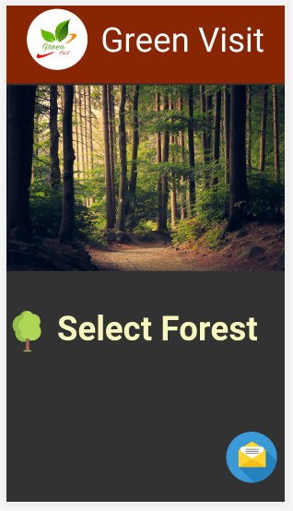

***SELECT FOREST***

*<?***xml version="1.0" encoding="utf-8"***?>*<**RelativeLayout xmlns:android="http://schemas.android.com/apk/res/android"  
 xmlns:app="http://schemas.android.com/apk/res-auto"  
 xmlns:tools="http://schemas.android.com/tools"  
 android:layout_width="match_parent"  
 android:layout_height="match_parent"  
 tools:context=".select_forest"  
 android:orientation="horizontal"  
 android:background="@color/white"**>  
  
 <**LinearLayout  
 android:layout_width="match_parent"  
 android:layout_height="60dp"  
 android:background="@color/colorAccent"** >  
  
 <**TextView  
 android:layout_width="wrap_content"  
 android:layout_height="match_parent"  
 android:text="Select Forest"  
 android:textSize="40dp"  
 android:layout_marginLeft="70dp"  
 android:textColor="@color/white"  
 android:textStyle="bold"** />  
 </**LinearLayout**>  
  
 <**ImageView  
 android:id="@+id/tr1"  
 android:layout_width="165dp"  
 android:layout_height="250dp"  
 android:src="@drawable/bandipur"  
 android:layout_marginTop="50dp"** />  
  
 <**ImageView  
 android:id="@+id/tr2"  
 android:layout_width="165dp"  
 android:layout_height="250dp"  
 android:layout_marginLeft="82dp"  
 android:layout_toRightOf="@+id/tr1"  
 android:src="@drawable/khasi"  
 android:layout_marginTop="50dp"**/>  
  
 <**ImageView  
 android:id="@+id/tr3"  
 android:layout_width="165dp"  
 android:layout_height="250dp"  
 android:layout_below="@+id/tr1"  
 android:layout_marginLeft="120dp"  
 android:layout_marginTop="-31dp"  
 android:src="@drawable/gir"** />  
  
  
 <**ImageView  
 android:id="@+id/tr4"  
 android:layout_width="165dp"  
 android:layout_height="250dp"  
 android:layout_below="@+id/tr3"  
 android:src="@drawable/jim"** />  
  
 <**ImageView  
 android:id="@+id/tr5"  
 android:layout_width="165dp"  
 android:layout_height="250dp"  
 android:layout_marginLeft="82dp"  
 android:layout_marginTop="515dp"  
 android:layout_toRightOf="@+id/tr4"  
 android:src="@drawable/keibul"** />  
  
  
  
  
  
</**RelativeLayout**>

